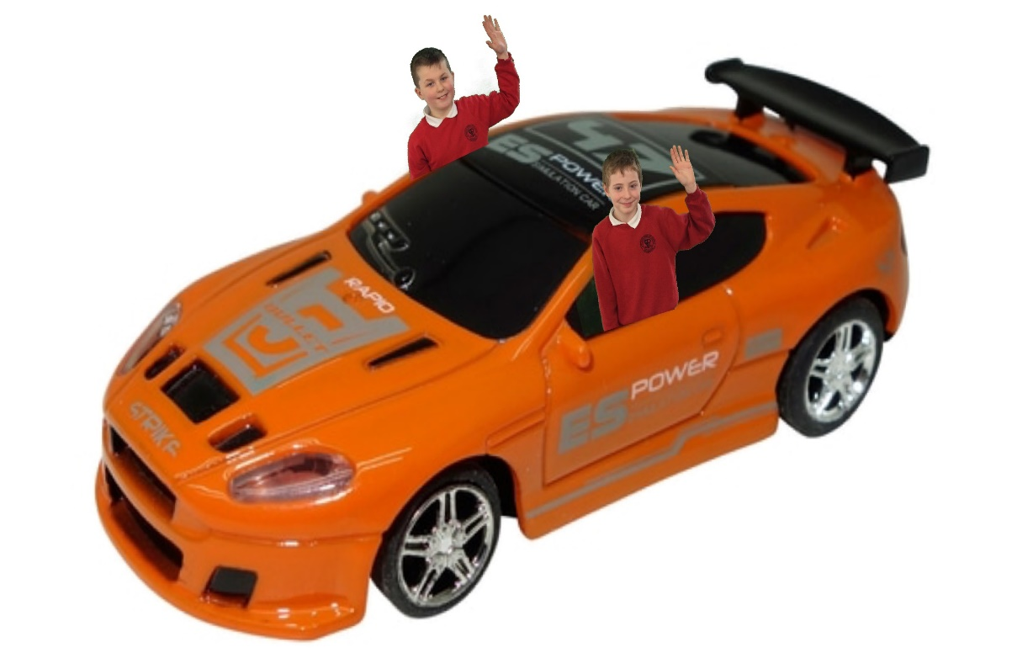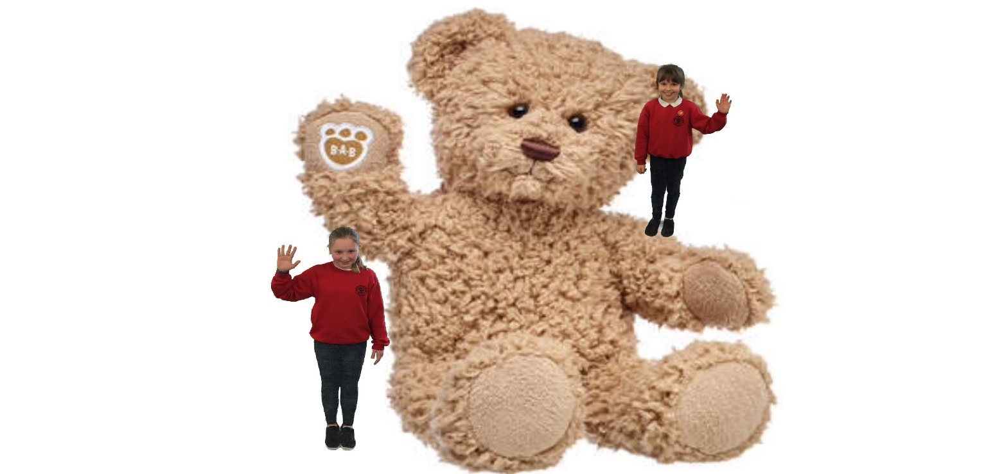

**Bring a Toy to School Day**

**On Friday 7th of February it’s bring a toy to school day.**

**You can bring any toy that you like but no electronics.**

**If in doubt about whether you are allowed to bring a particular toy, ask your teacher if it is it ok.**

**Remember if you would like to bring a toy to school on Friday the 7th of February it is only £1.00**

