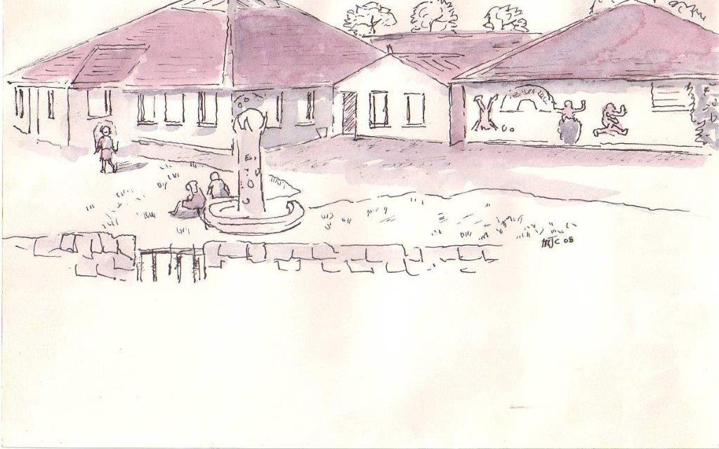

Fire Evacuation Policy
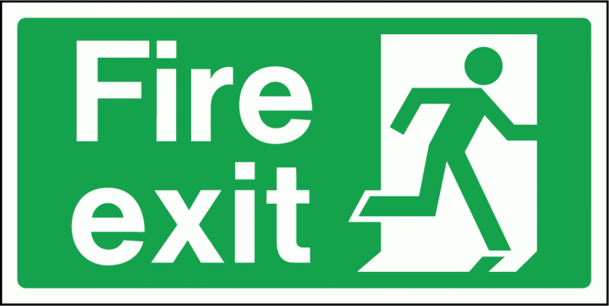

Approved by Board of Governors: December 2015
Date to be Reviewed: December 2016
FIRE DRILL PROCEDURE
SIGNAL: Bell ringing: continuous sounding
PROCEDURE DURING CLASS TIME
- Children exit classroom via main door and WALK QUIETLY in orderly lines.
- Children evacuate the building by designated routes to the assembly area (i.e.
school car park).
Teachers:
- Take your CLASS LIST
- Check that all children are out of the classroom.
- Check that all exits are clear.
- Close classroom door. DO NOT LOCK. (Later entry may be required.)
- In assembly area, teacher takes roll and accounts for each child.
- Children in classrooms other than their own are to remain with that class until given permission to rejoin their class.
- Children remain in orderly and silent lines until a clear signal is given by principal to either return to school or remain outside of school grounds.
PROCEDURE USED BEFORE SCHOOL, DURING BREAK & LUNCH
- Children WALK to where they usually line up in the yard.
- Children wait in orderly and silent lines for their teacher, or other supervising adult, to lead them to their proper assembly area.
PROCEDURE DURING P.E.
Teacher, or supervising adult, stops play, organises class (es) into silent and orderly lines and leads class(es) to assembly area.
PROCEDURE WHEN NOT IN YOUR OWN CLASSROOM
- Teachers should be familiar with assembly area and evacuation route designated for that classroom or area.
- The ROLL/REGISTER should accompany the class and be used by the teacher, or supervising adult, to account for all students.
ALL SCHOOL PERSONNEL, CERTIFICATED AND CLASSIFIED ARE TO PARTICIPATE IN ALL FIRE DRILLS. Parents, guests and community people on the grounds during a drill must participate
.

