




ST MARY’S PRIMARY SCHOOL
 | Monday | Tuesday | Wednesday | Thursday | Friday
Week One  7/10/19 |  |  |  | CHICKEN CURRY & RICE OR CHICKEN IN GRAVY  CARROTS/SWEETCORN  MASH/ROAST POTATOES  MUFFIN CAKE AND  GOOOOOEEY CUSTARD | VEGETABLE SOUP  CRUSTY /WHEATEN BREAD  STEAK BURGER IN BAP with CHEESE  CHICKEN SALAD ROLL  FLAKEMEAL BISCUIT ,FRUIT AND MILKSHAKE
Week Two

14/10/19
Week Three

21/10/19
Week Four

28/10/19

OVEN BAKED BACON SLICE/STUFFED BACON ROLL OR CHICKEN PASTA BAKE
PEAS GRAVY
MASHED POTATOES
BANANA /MARBLE CAKE AND CUSTARD
LASAGNE OR
OVEN BAKED SAUSAGES

SWEETCORN / BEANS
MASH/CHIPS

FROZEN MOUSSE & FRESH FRUIT
CHICKEN GOUJONS (HMOC) OR FISH PIE
TOSSED SALAD
CARROTS PASTA
MASHED POTATOES
GRAVY

CHOCOLATE CAKE & CUSTARD

www.schoolfoodni.com

Bread, Fresh Fruit, Yoghurt, Milk and Water are available daily

If you require any additional Information on allergens or Special diets please contact the school in the first instance

MINCE/COTTAGE PIE OR CHICKEN IN GRAVY
CARROTS
MASH POTATOES

APPLE CRUMBLE /
SHORTBREAD & CUSTARD
MACARONNI CHEESE OR CHICKEN NUGGETS
PEAS/BEANS
MASH/ CHIPS

SWISSROLL, FRUIT AND MILKSHAKE

STEAK BURGER OR BREADED FISH
CARROTS /COLESLAW
OVEN BAKED ROASTIES / MASH GRAVY

CORNFLAKE SQ & CUSTARD

OVEN BAKED BACON SLICE OR CHICKEN IN GRAVY STUFFING
CABBAGE/CARROTS
MASH PASTA

CHOCOLATE CAKE & CUSTARD
CHICKEN CURRY & RICE OR FISH FINGERS
Naan Bread
PEAS GRAVY
MASHED POTATO

ICECREAM AND SPOOOOOOKY JELLY
.

SPAGHETTI BOLOGNAISE or CHICKEN DRUMSTICKS

CARROTS GRAVY
MASHED POTATOES

GINGER BISCUIT & CUSTARD
SALMON FISHCAKE or HOMEMADE PIZZA
BAKED BEANS
COLESLAW/SWEETCORN
MASH or CHIPS

RICE PUDDING & FRUIT OR SELECTION OF YOGHURT
CHICKEN GOUJONS OR HARVEST STEW GRAVY
CARROTS/ BROCCOLI
MASH RICE

SPONGE CAKE ,ORANGES & CUSTARD

SAVOURY MINCE OR CHICKEN IN GRAVY

CARROTS /PEAS
MASH

CHOCOLATE BROWNIE & CUSTARD
CAULDROM OF WITCHES BROTH
CRUSTY ROLL
RED HOT BANGERS OR FANGTASTIC CHICKEN SALAD BAP
I SCREAM ,WAFER & FRUIT

ICECREAM WAFER
S.C
S.C

S.C

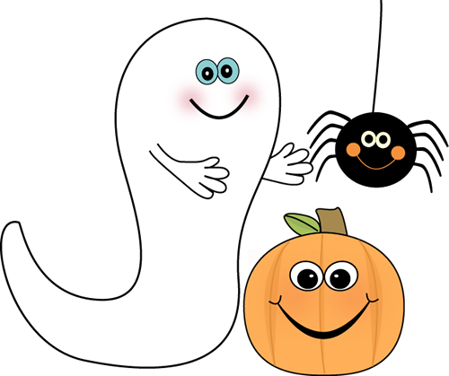

S.C


S.C

